The Devil in the White City  By Erik Larson  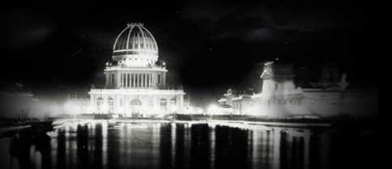  Reading Dates:  #1: 11-47: January 7  #2: 48-109: January 12  #3: 113-182: January 16  #4: 183-231: January 21  #5: 235-273: January 26  #6: 274-396: January 30  For each reading date:  Label each reading date’s work by its number and bring to class on the selection’s due date.  - Write 1 (AP style) multiple choice question.  - Write one FRQ prompt. Alternate between rhetorical analysis and argument. (You may need to select a cutting from the selection.)  - Write five questions for discussion that show evidence of critical reading.  - Write a 175-200 word critical analysis commentary on the selection that includes specific details.  - Read closely, very closely.  Prepare for a quiz on anything (including vocabulary words you don’t know, historical facts, and allusions.) | The Devil in the White City  By Erik Larson  Reading Dates:  #1: 11-47: January 7  #2: 48-109: January 12  #3: 113-182: January 16  #4: 183-231: January 21  #5: 235-273: January 26  #6: 274-396: January 30  For each reading date:  Label each reading date’s work by its number and bring to class on the selection’s due date.  - Write 1 (AP style) multiple choice question.  - Write one FRQ prompt. Alternate between rhetorical analysis and argument. (You may need to select a cutting from the selection.)  - Write five questions for discussion that show evidence of critical reading.  - Write a 175-200 word critical analysis commentary on the selection that includes specific details.  - Read closely, very closely.  Prepare for a quiz on anything (including vocabulary words you don’t know, historical facts, and allusions.) | The Devil in the White City  By Erik Larson  Reading Dates:  #1: 11-47: January 7  #2: 48-109: January 12  #3: 113-182: January 16  #4: 183-231: January 21  #5: 235-273: January 26  #6: 274-396: January 30  For each reading date:  Label each reading date’s work by its number and bring to class on the selection’s due date.  - Write 1 (AP style) multiple choice question.  - Write one FRQ prompt. Alternate between rhetorical analysis and argument. (You may need to select a cutting from the selection.)  - Write five questions for discussion that show evidence of critical reading.  - Write a 175-200 word critical analysis commentary on the selection that includes specific details.  - Read closely, very closely.  Prepare for a quiz on anything (including vocabulary words you don’t know, historical facts, and allusions.) | The Devil in the White City  By Erik Larson  Reading Dates:  #1: 11-47: January 7  #2: 48-109: January 12  #3: 113-182: January 16  #4: 183-231: January 21  #5: 235-273: January 26  #6: 274-396: January 30  For each reading date:  Label each reading date’s work by its number and bring to class on the selection’s due date.  - Write 1 (AP style) multiple choice question.  - Write one FRQ prompt. Alternate between rhetorical analysis and argument. (You may need to select a cutting from the selection.)  - Write five questions for discussion that show evidence of critical reading.  - Write a 175-200 word critical analysis commentary on the selection that includes specific details.  - Read closely, very closely.  Prepare for a quiz on anything!

